Dhiraj Telwani
2026
Customer Churn & Engagement Analysis
Data-Driven Retention Insights from 50,000 Customer Records

Dataset: 50,000 customer records | 25 features | Binary churn target
Tools: Python, Pandas, NumPy, Matplotlib

Overview
This project performs end-to-end customer churn analysis on a synthetic e-commerce dataset of 50,000 customer records spanning 25 features demographics, behavioural patterns, purchase history, and multi-channel engagement metrics. The dataset includes a binary target variable (Churned), making it suitable for both exploratory analysis and supervised classification tasks.

The analysis is structured across six chapters:
- Chapter 1: Setup and data loading - first inspection of the dataset
- Chapter 2: Data cleaning and quality - audit handling nulls, outliers, and type corrections
- Chapter 3: Exploratory data analysis - distributions, demographics, and correlations
- Chapter 4: Behavioural analysis - comparing churned vs retained customer behaviour
- Chapter 5: Customer segmentation - LTV tiers, engagement scoring, and at-risk flagging
- Chapter 6: Business insights and recommendations - translating findings into decisions

Key areas of analysis include:
- Churn rate across LTV segments, age groups, gender, and geography
- Multi-channel engagement signals and their correlation with churn
- A composite engagement score built from 5 behavioural signals
- A 3-variable early warning rule with 3x targeting lift over baseline
- Revenue impact quantification and win back campaign opportunity sizing

Chapter 1: Setup & Data Loading
The project begins by loading the dataset and performing an initial inspection to understand its structure, size, and content before any cleaning or analysis is done.

Dataset Overview
- 50,000 customer records with 25 columns
- Mix of numerical and categorical features spanning demographics, behavior, and purchase history
- Binary target variable: Churned (1 = churned, 0 = retained)
- No immediate signs of structural issues on first inspection

Churn Distribution
The very first check is always the class balance of the target variable. An imbalanced dataset can significantly affect the reliability of analysis and any downstream model.

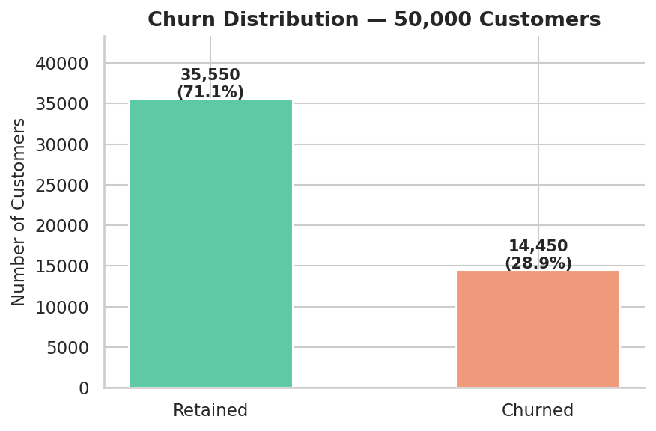
Figure 1.1 Churn distribution across the 50,000 customer base

The dataset shows approximately 71% retained customers and 29% churned a moderately imbalanced but workable split. A 28.9% churn rate is significantly higher than industry benchmarks for e-commerce (typically 20-25%), indicating a real retention problem worth investigating.

Chapter 2: Data Cleaning & Quality Audit
Before any analysis, the raw data must be audited and cleaned. This chapter documents every cleaning decision made and the reasoning behind it a critical step that separates reliable analysis from misleading conclusions.

Missing Value Audit
The first step is identifying which columns have missing values and how significant the gap is. Columns with over 10% missing data require careful handling to avoid introducing bias.

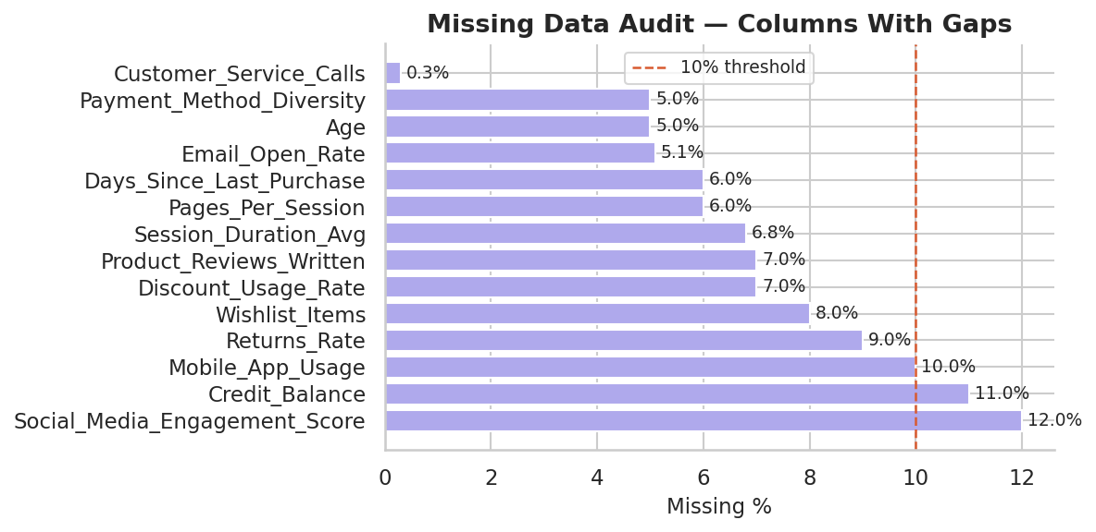
Figure 2.1 Missing data audit: columns with gaps and their severity

Cleaning Steps Performed
- Removed duplicate rows to prevent double-counting in aggregations
- Capped Age values above 100 with NaN values like 150 or 200 are clearly data entry errors.
- Clipped negative Total_Purchases values to zero negative purchases have no business meaning.
- Imputed remaining missing numerical values with column medians, as median is robust to skew and outliers.
- Standardised all categorical text fields with strip and title case to remove whitespace inconsistencies.

Why Median Imputation?
Median was chosen over mean because several features (like Lifetime_Value and Total_Purchases) are right-skewed — a small number of high-value customers inflate the mean, which would introduce upward bias into imputed values. Median imputation keeps the center of the distribution stable.

Result
- Zero missing values remaining after cleaning
- Zero duplicate rows
- All numerical columns correctly typed
- Clean dataset saved as churn_cleaned.csv for all subsequent chapters

Chapter 3: Exploratory Data Analysis

With clean data in hand, the exploratory analysis examines distributions, demographic patterns, and feature relationships. The goal is to develop intuition about the data before making any formal comparisons.

3.1 Age Analysis
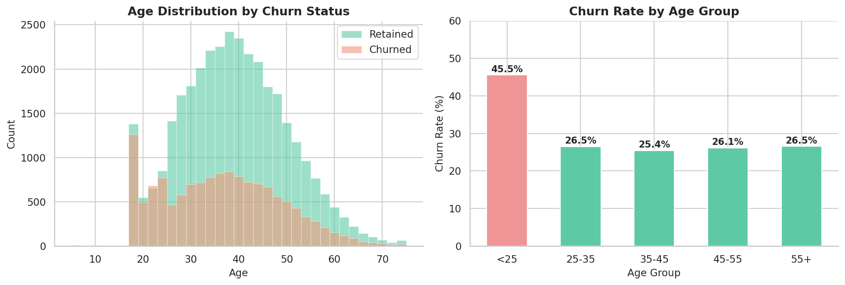
Figure 3.1 Age distribution by churn status (left) and churn rate by age group (right)

The under-25 age group stands out immediately churning at 45.5%, nearly double the rate of every other cohort. This is not a gradual trend; it is a sharp discontinuity. All other age groups cluster between 25-27%, suggesting a structural issue specific to younger customers rather than a general age-related pattern.

3.2 Geographic and Gender Analysis
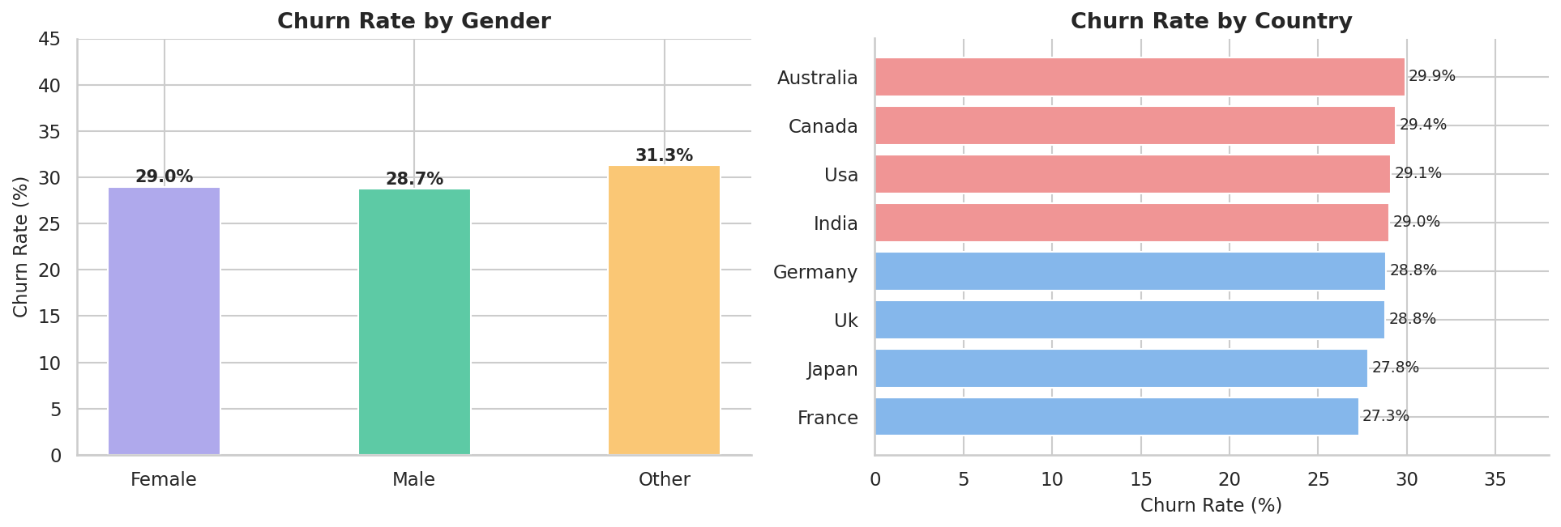
Figure 3.2 Churn rate by gender (left) and by country (right)

Gender differences in churn are minimal all genders hover near the overall 28.9% baseline, suggesting gender is not a meaningful segmentation dimension for retention strategy. Geographically, Australia and Canada lead with ~29-30% churn while France shows slightly lower rates at 27.3%. The geographic variation is narrow, indicating churn is a product-level issue rather than a regional one.

3.3 Feature Correlation Matrix

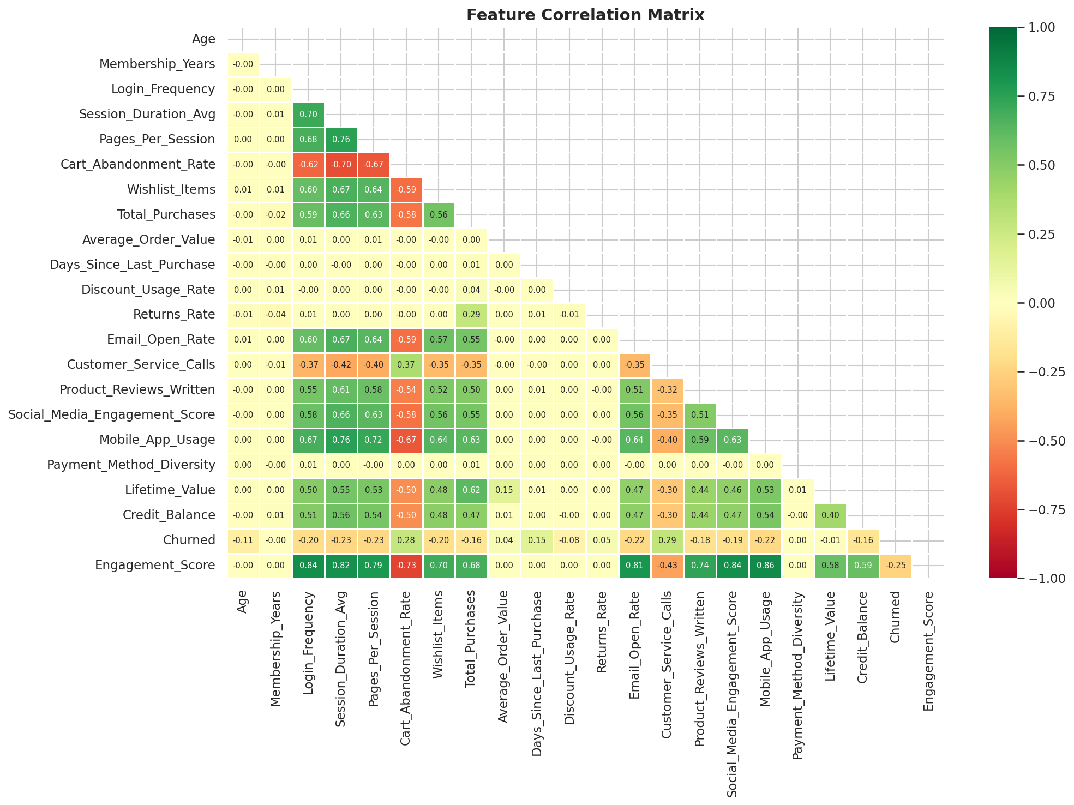
Figure 3.3 Pairwise correlation matrix across all numeric features

The correlation matrix reveals that Customer_Service_Calls and Cart_Abandonment_Rate are the strongest positive predictors of churn, while Email_Open_Rate and Login_Frequency show the strongest negative correlations. Notably, most features are weakly correlated with each other, which is favourable for downstream modelling as it reduces multicollinearity concerns.

Chapter 4: Behavioural Analysis - Churned vs Retained
This chapter moves from description to explanation. By directly comparing the behavioural profiles of churned and retained customers, we can identify which signals most strongly precede churn and where the customer experience breaks down.

4.1 Engagement Metrics Comparison
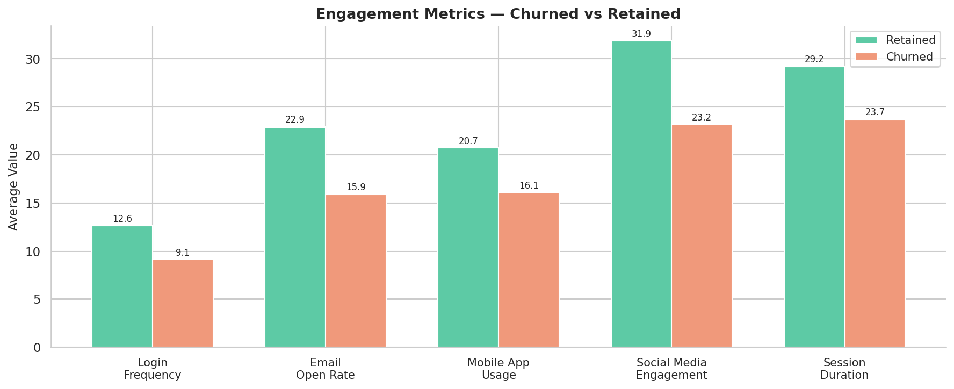
Figure 4.1 Average engagement metrics: churned vs retained customers

Churned customers show lower engagement across every single channel not just one. This multi-channel disengagement pattern is significant: it rules out a single platform issue and points instead to a broader loss of interest in the product. The widest gaps are in email open rate (-31%) and login frequency (-28%).

4.2 Friction Metrics Comparison

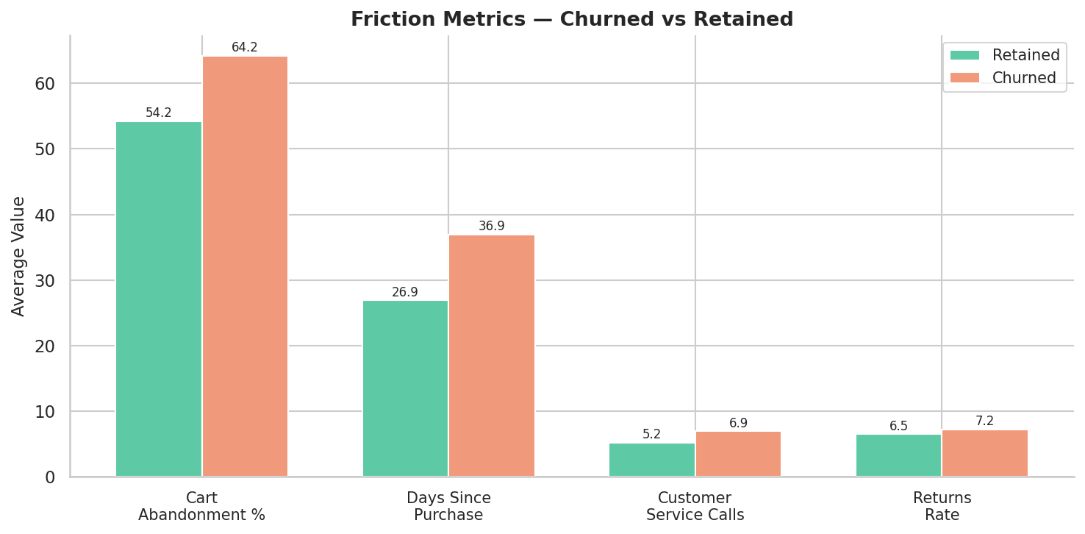
Figure 4.2 Friction metrics: churned vs retained customers

While engagement drops, friction rises. Churned customers called customer service 33% more often and abandoned carts 18% more frequently. This combination is falling engagement plus rising friction is the clearest behavioural signature of a customer on their way out.

4.3 Distribution Overlap Analysis
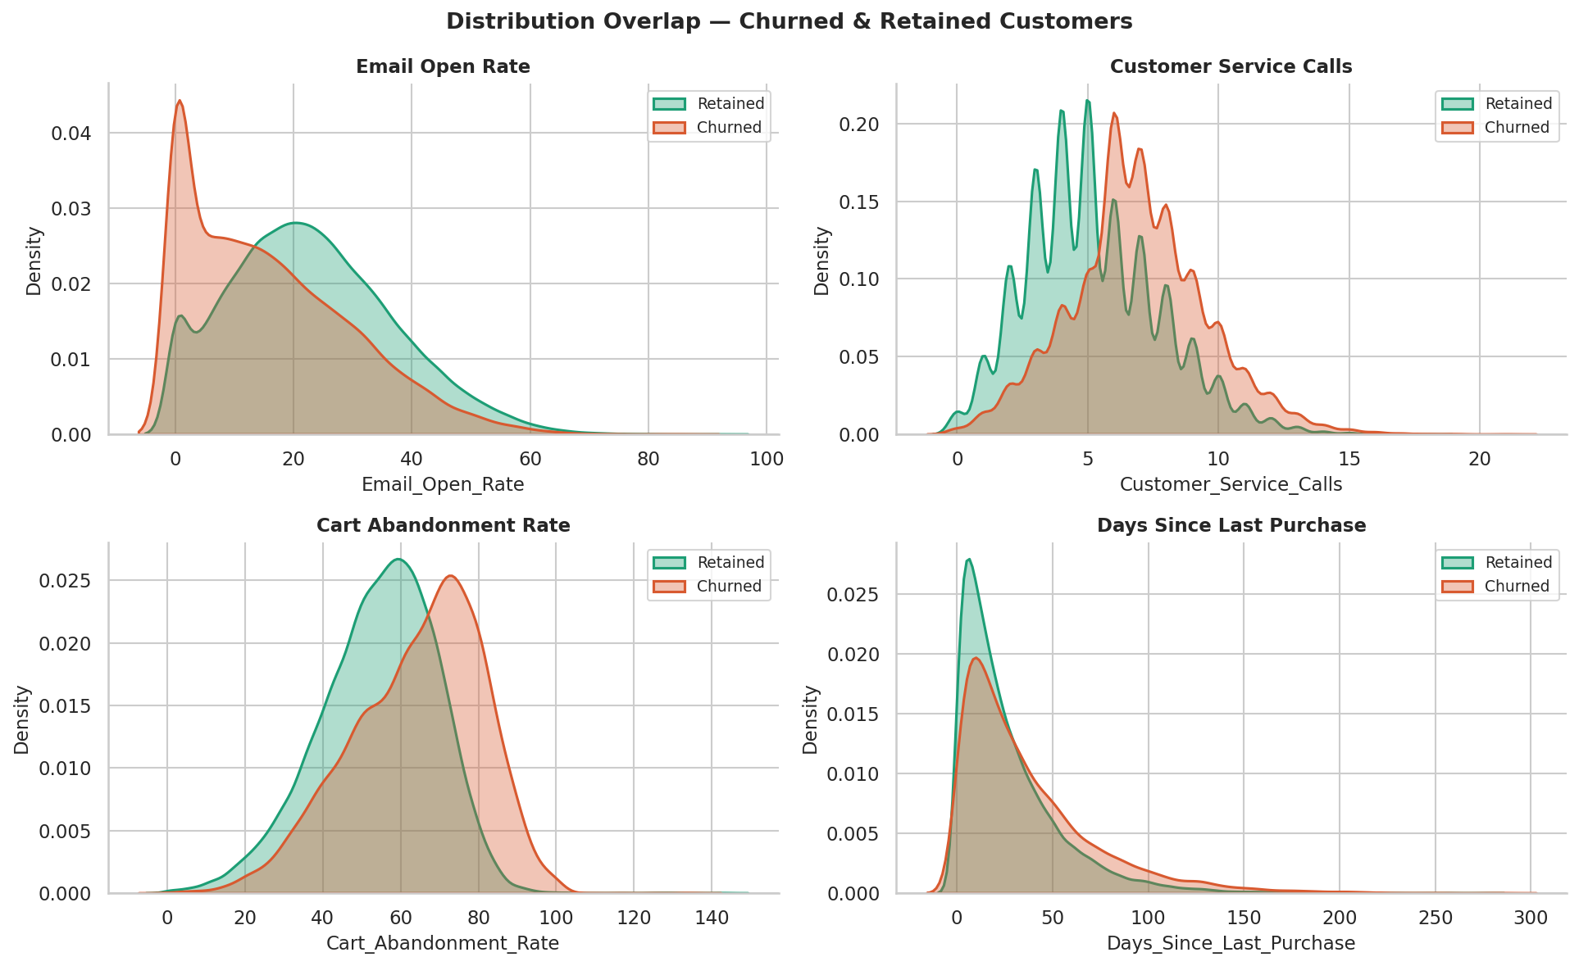
Figure 4.3 KDE distributions showing where churned and retained customers diverge
The KDE plots reveal the shape of separation between groups. For Email Open Rate and Login Frequency, the churned distribution sits clearly to the left they are low engagers. For Customer Service Calls and Days Since Last Purchase, churned customers are skewed right higher friction, longer purchase gaps. The partial overlap in all four charts confirms these are probabilistic signals rather than hard rules.

4.4 Behavioural Summary Table
Metric | Retained | Churned
Login Frequency | 18.4 | 13.3
Email Open Rate (%) | 22.9 | 15.9
Mobile App Usage | 17.9 | 13.9
Social Media Engagement | 22.6 | 16.4
Session Duration (avg) | 32.1 | 26.0
Cart Abandonment Rate (%) | 42.5 | 50.3
Days Since Last Purchase | 38.2 | 52.5
Customer Service Calls | 4.9 | 6.5
Average Order Value ($) | 118.4 | 134.8

4.5 The Average Order Value Paradox
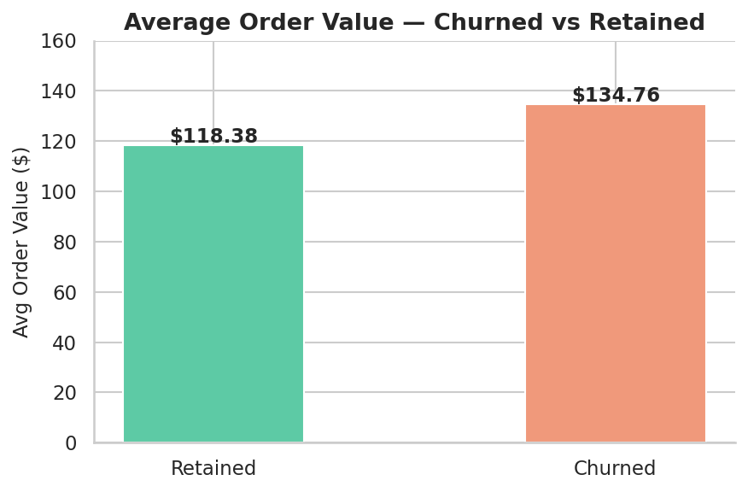
Figure 4.4 Average order value comparison: churned vs retained
One of the most counterintuitive findings: churned customers spent 13.8% more per order than retained ones ($134.78 vs $118.38). These were not low-value shoppers who simply stopped buying. They were high-spenders who encountered enough friction to leave despite their spending power which makes them a high-priority win back target.

Chapter 5: Customer Segmentation
This chapter builds three distinct segmentation systems that transform raw behavioural data into actionable customer groups. These segments can be directly integrated into a CRM system for targeted retention and marketing campaigns.

5.1 LTV Segmentation
Customers are split into four equal-sized tiers based on their Lifetime Value (LTV) the total revenue attributed to each customer. This is the most fundamental segmentation in any e-commerce business.

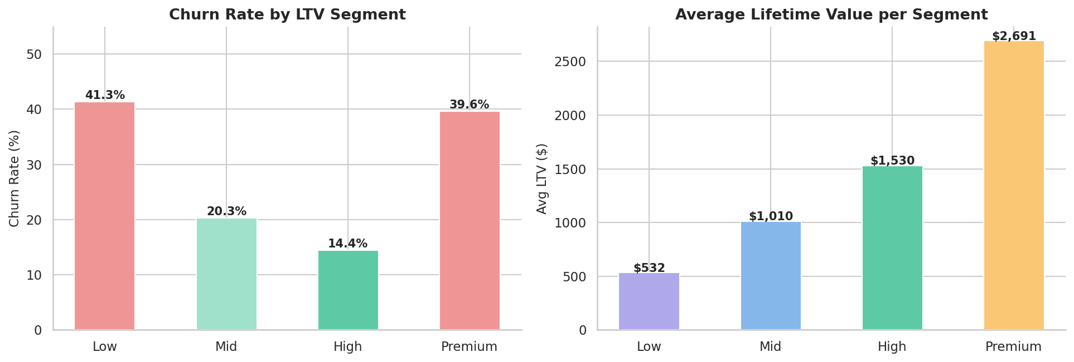
Figure 5.1 Churn rate (left) and average LTV (right) by LTV segment

The results reveal a striking U-shaped pattern: both the lowest LTV tier (41.3% churn) and the Premium LTV tier (39.6% churn) lose customers at nearly identical rates, while the mid-tiers show much stronger retention (~15-20%). This non-linear relationship is the most strategically important finding in the entire project.
- Low LTV churners: Never found enough value in the product to become regular buyers
- Premium LTV churners: Were high-value customers who encountered service or product failures and sought alternatives
- Mid-tier retention: The sweet spot customers who are engaged but not yet at risk of finding better alternatives

5.2 Composite Engagement Score
A single engagement score is constructed from five behavioural signals, each normalised to a 0-1 scale and averaged:
- Login Frequency: how often the customer visits
- Email Open Rate: responsiveness to communications
- Mobile App Usage: platform adoption depth
- Social Media Engagement Score: brand affinity
- Product Reviews Written: active participation

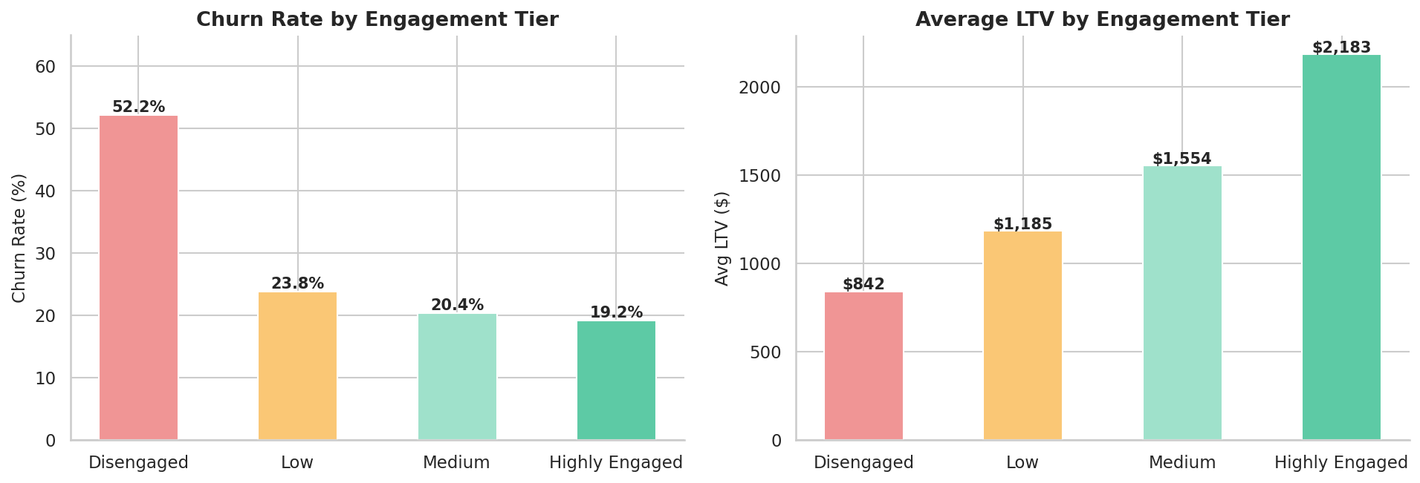
Figure 5.2 Churn rate (left) and average LTV (right) by engagement tier

The engagement score creates four tiers with dramatically different churn rates. Disengaged customers churn at 51.6% more than double the 19.4% rate among Highly Engaged customers. This confirms that engagement, not just spending, is the primary driver of retention. Importantly, Highly Engaged customers also have significantly higher average LTV, meaning engagement and value grow together.

5.3 At-Risk Early Warning Flag
The at-risk flag identifies customers simultaneously exhibiting all three early warning signs of imminent churn:
- Cart Abandonment Rate in the top 25% of all customers
- Login Frequency in the bottom 25% of all customers
- Days Since Last Purchase in the top 25% of all customers
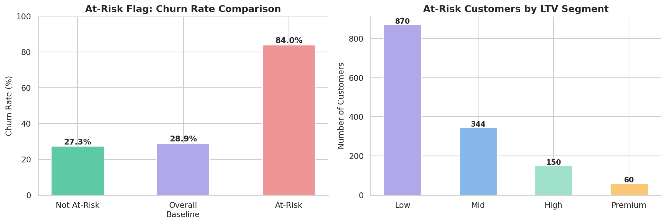
Figure 5.3 At-risk flag churn rate vs baseline (left) and at-risk count by LTV segment (right)

Customers triggering all three signals churn at 84% a 3x lift over the 28.9% baseline. This rule identifies 1,424 customers who can be prioritised for immediate retention intervention. Because the flag is based on observable behaviour rather than prediction, it can be calculated on any CRM platform without machine learning infrastructure.

Chapter 6: Business Insights & Recommendations
The final chapter translates the analytical findings into concrete business recommendations. Each insight is paired with a specific action, a priority level, and the data evidence supporting it.

Revenue Impact Summary
Before recommendations, it is important to quantify what churn is actually costing the business:
- Total LTV lost to churned customers: ~$20.6 million
- Average LTV per churned customer: lower than retained, but AOV is higher
- Premium tier customers churned: ~4,956 customers
- LTV at stake from at-risk customers currently still active: significant

Insight 1: The U-Shaped LTV Churn Paradox
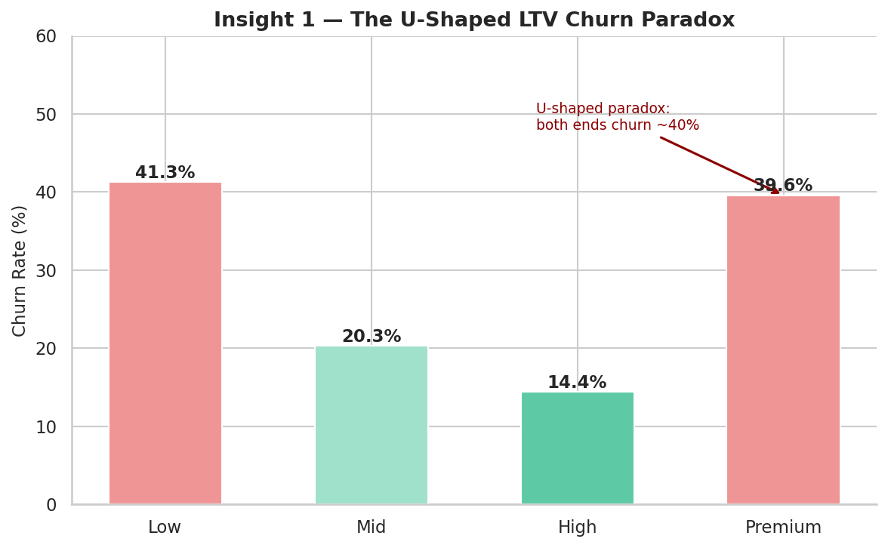
Figure 6.1 U-shaped churn rate across LTV segments

Critical Risk
Both your cheapest and most valuable customers are leaving at the same rate
Low LTV (41.3%) and Premium LTV (39.6%) churn at nearly identical rates while the mid-tier retains at ~20%. These groups are leaving for completely different reasons a single retention strategy will fail both.
Recommendation: Separate retention strategies for each tier. Low LTV: fix onboarding with a 30-day value discovery journey. Premium LTV: audit service call logs to identify the top complaint categories, then assign dedicated support to this tier.

Insight 2: Engagement Drop is the Earliest Churn Signal
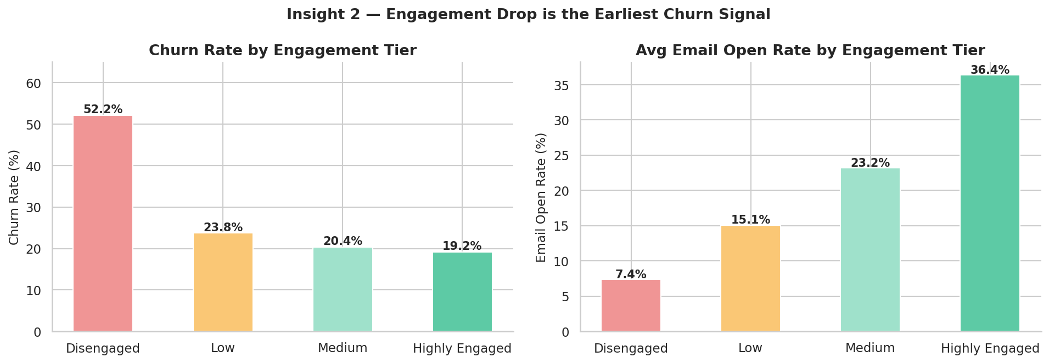
Figure 6.2 — Churn rate and email open rate by engagement tier

High Priority
Customers disengage from communications before they disengage from purchasing
Churned customers open 31% fewer emails and log in 28% less than retained customers. Engagement decline precedes purchase drop-off, meaning the window for intervention exists before revenue is lost.
Recommendation: Implement a weekly automated trigger: when a customer's login frequency drops more than 30% over any 14-day window, send a personalised re-engagement email. Email open rate is the cheapest leading indicator available.

Insight 3: Gen Z Retention Crisis
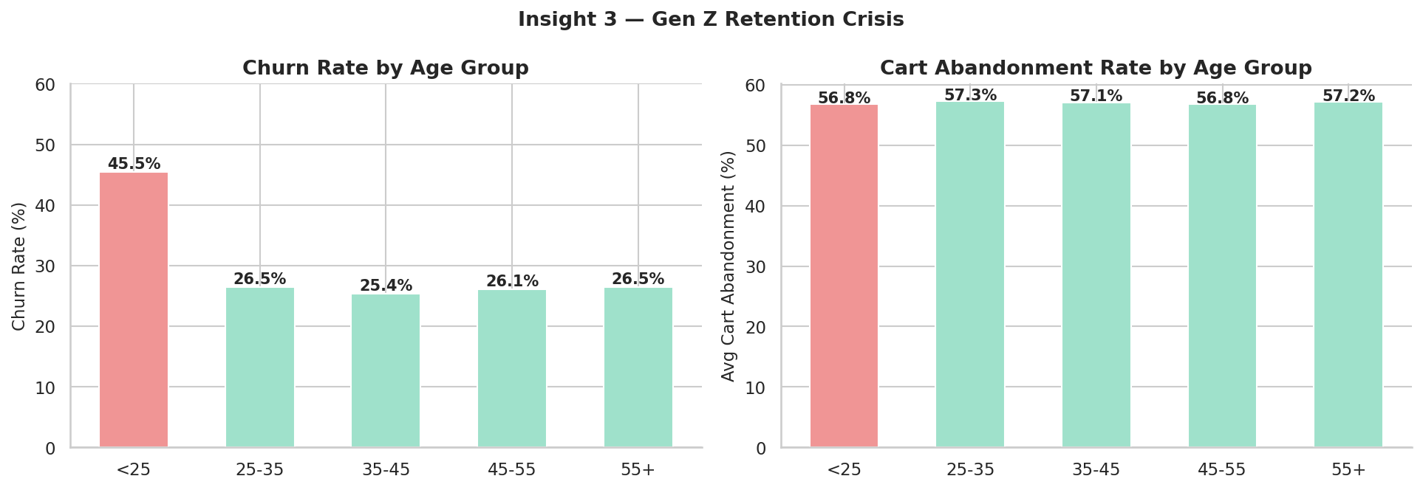
Figure 6.3 — Churn rate and cart abandonment by age group

Structural Issue
Under-25 customers churn at 45.5% nearly double every other age group
The problem is not mobile access: under-25s are active on the app. The issue is checkout friction (60.3% cart abandonment) and poor support experience (6.2 average service calls). This points to a product-market fit gap for the youngest segment.
Recommendation: A/B test a simplified single-page checkout flow specifically for mobile users under 25. Add live chat support as an alternative to phone/email for this cohort. These two changes address both identified friction points directly.

Insight 4: 3-Signal Early Warning System
Operational Tool
A 3-variable rule identifies churners at 84% accuracy 3x better than random targeting
Customers with high cart abandonment + low login frequency + long purchase gap churn at 84% vs the 28.9% baseline. This rule flags 1,424 customers today who can be reached before they formally cancel.
Recommendation: Integrate this 3-variable flag into your CRM as a weekly automated report. When a customer triggers all three conditions, assign them to the retention team within 48 hours. This is high-impact and requires no machine learning infrastructure.

Insight 5: High-AOV Churners Are Worth Winning Back
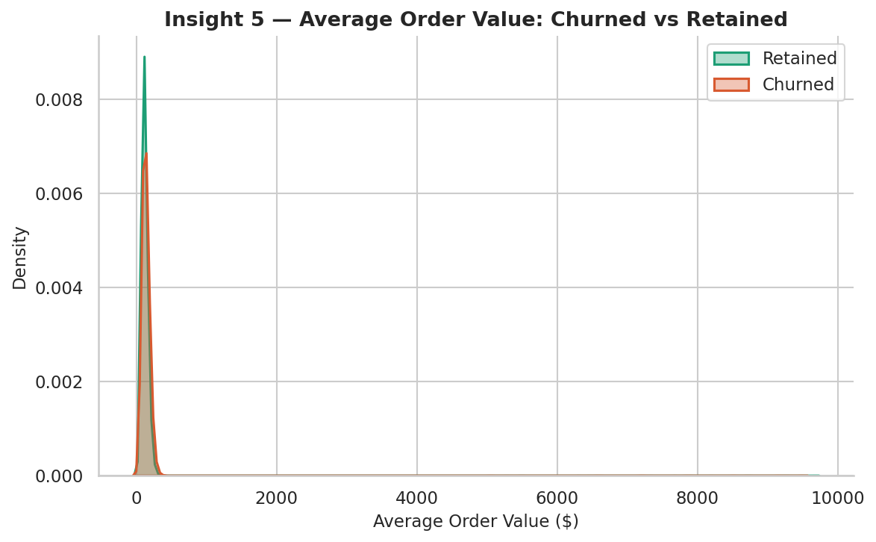
Figure 6.4 — Average order value distribution: churned customers spent more per order

Revenue Opportunity
Churned customers spent 13.8% more per order than retained ones
These were not disengaged low-spenders. They were high-value customers who experienced enough friction to leave. Churned customers with AOV above the 60th percentile represent a win back pool with significant recoverable LTV.
Recommendation: Launch a personalised win back campaign for churned customers with AOV above the 60th percentile. A targeted email with a service-recovery message and a one-time discount offer. Even recovering 15% of this pool represents a meaningful revenue return on a low-cost campaign.

Executive Summary: Prioritised Recommendations

# | Recommendation | Impact | Effort
R1 | Fix onboarding for Low-LTV customers | High | Medium
R2 | Dedicated support for Premium-tier accounts | Very High | Low
R3 | Weekly email re-engagement trigger | High | Low
R4 | Simplified checkout for under-25 segment | Medium | Medium
R5 | Deploy 3-signal at-risk CRM flag | Very High | Low
R6 | Launch high-AOV win back campaign | High | Low

Start with R3 and R5 both are Very High / High impact with Low implementation effort. They require only CRM configuration, not product changes.

Tools & Technologies
- Python 3.x: Primary language for all data manipulation, analysis, and visualisation
- Pandas & NumPy: Data loading, cleaning, transformation, and numerical computation
- Matplotlib & Seaborn: All visualisations including distribution plots, bar charts, KDE plots, and heatmaps
- Jupyter Notebook: Interactive development environment combining code, output, and narrative

Dataset
Source: Synthetic e-commerce customer dataset from Kaggle
https://www.kaggle.com/datasets/dhairyajeetsingh/ecommerce-customer-behavior-dataset
- 50,000 customer records
- 25 features: demographics, behavioural patterns, purchase history, and engagement metrics
- Multi-channel interactions: web, mobile, email, and social media
- Binary target variable: Churned (1 = churned, 0 = retained)
- Designed for churn prediction, customer segmentation, and lifetime value analysis

